# Credit Risk Modeling and Assessment

## AIM

The Credit Risk Modeling and Assessment project aims to evaluate the credit risk associated with loan applicants by analyzing various factors such as loan amount, interest rate, credit score, employment status, and other relevant metrics. The objective is to identify key risk factors and support data-driven decisions for loan approvals and risk management.

## FEATURES

The dataset used for this analysis includes the following columns and their respective data types:

* **Loan_ID**: Unique identifier for each loan.
* **Customer**: Unique identifier for each customer.
* **Loan Amount**: Total amount of the loan.
* **Interest Rate**: Interest rate applied to the loan.
* **Loan Term**: Term of the loan in months.
* **Credit Score**: Credit score of the customer.
* **Annual Income**: Annual income of the customer.
* **Employment Status**: Employment status of the customer.
* **Debt_to_Income_Ratio**: Ratio of debt to income for the customer.
* **Loan Purpose**: Purpose of the loan.
* **Late Payments**: Number of late payments by the customer.
* **Defaulted**: Indicator if the loan was defaulted.
* **Age**: Age of the customer.
* **Home Ownership**: Home ownership status of the customer.
* **Loan Status**: Status of the loan.

## METHODOLOGY

1. **Data Cleaning and Preparation**:
   * Removed duplicate records.
   * Handled missing values by either imputing or removing incomplete records.
   * Standardized date formats and ensured data consistency.
2. **SQL Analysis**:
   * Performed data extraction and transformation using SQL queries.
   * Aggregated and summarized data for key metrics.
3. **Data Visualization**:
   * Created a Power BI dashboard to visualize key metrics and trends.
   * Included various charts and graphs for a comprehensive analysis.

## OUTPUT

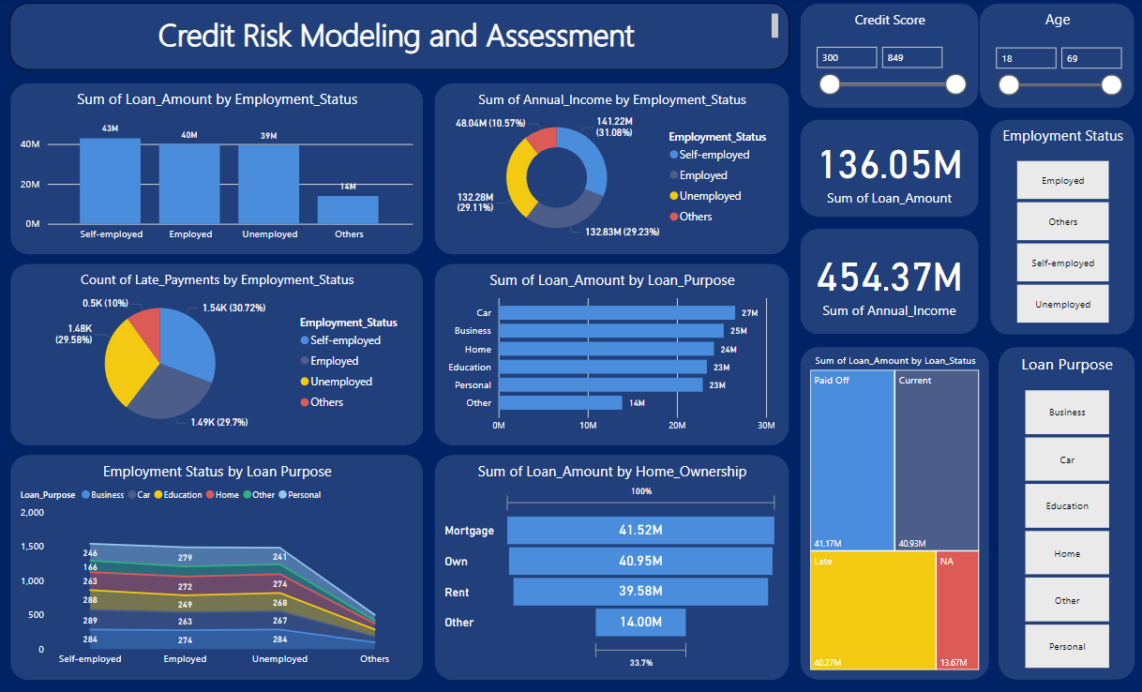

## RESULT ANALYSIS

1. **Sum of Loan Amount by Employment Status**:
   * **Chart**: Bar chart showing the total loan amount by employment status.
   * **Outcome**: Self-employed and employed individuals had the highest loan amounts, while others had the least.
2. **Sum of Annual Income by Employment Status**:
   * **Chart**: Pie chart showing the sum of annual income by employment status.
   * **Outcome**: Employed and unemployed individuals had the highest annual incomes, making up the largest portions of the pie.
3. **Count of Late Payments by Employment Status**:
   * **Chart**: Pie chart showing the count of late payments by employment status.
   * **Outcome**: Self-employed individuals had the highest count of late payments, followed closely by employed individuals.
4. **Sum of Loan Amount by Loan Purpose**:
   * **Chart**: Horizontal bar chart showing the total loan amount by loan purpose.
   * **Outcome**: Loans for cars and businesses had the highest amounts, while loans for education and others had the least.
5. **Employment Status by Loan Purpose**:
   * **Chart**: Line chart showing employment status across different loan purposes.
   * **Outcome**: The majority of loans were taken for business and car purposes by self-employed individuals.
6. **Sum of Loan Amount by Home Ownership**:
   * **Chart**: Bar chart showing the total loan amount by home ownership status.
   * **Outcome**: Mortgage holders had the highest loan amounts, followed by those who own their homes outright.
7. **Sum of Loan Amount by Loan Status**:
   * **Chart**: Treemap showing the sum of loan amounts by loan status.
   * **Outcome**: Paid off loans had the highest amounts, indicating successful loan completions.

## SUMMARY OF ANALYSIS

Overall, the Credit Risk Modeling and Assessment dashboard provided valuable insights into loan performance, customer demographics, and borrowing patterns. Key findings included the dominance of self-employed and employed individuals in loan amounts, the significant proportion of late payments among self-employed individuals, and the high loan amounts associated with car and business purposes.

These insights can help guide future lending strategies, risk management, and customer targeting to improve loan performance and customer satisfaction.